PRODUCTS SPECIFICATION
FLLED30MP 30W LED Floodlight
(110V 30W minipod LED light)

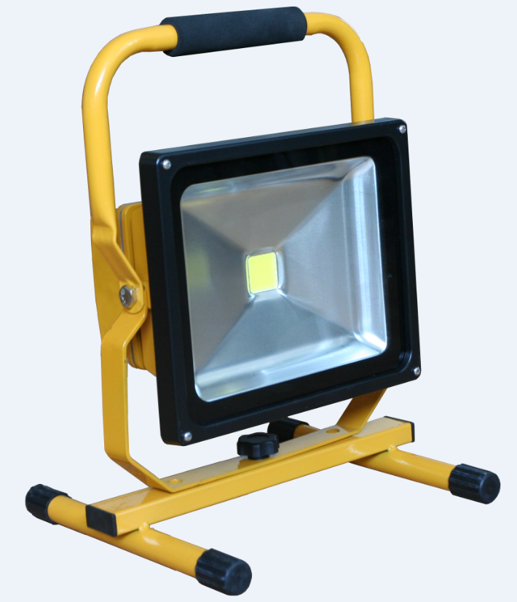

Product name: LED FloodLight
Item No : FLLED30MP
Power : 30Watt
LED : 1 pc COB x 30Watt
Input Voltage: AC 110Voltage

【Datasheet 】

Type | Product | LED FloodLight
Type | Modle No | FLLED30MP
Type | Product Type | outdoor Lighting
Type | Safety Level | Class I
Type | IP Level | IP44
Type | Safety Certificates | CE
Type | RoHS Directive | Compliant
Electronical | Input Voltage | 110 AC
Electronical | Frequency | 50/60Hz
Electronical | Power | 30Watt
Electronical | Power factor( PF) | ＞90％
Electronical | Total Harmonic Distortion | ＜20％
Optical | Cover Material | Tempered glass lens
Optical | The whole lamp light Angle | 120°
Optical | LED Quantity | 1
Optical | LED Package | COB
Optical | Luminous Efficiency(Lm/W) | ≥80Lm/W
Optical | LED luminous | Warm white | 2559LM
Optical | LED luminous | Pure white | 2860LM
Optical | LED luminous | Cold white | 2790LM
Optical | Color temperature(CCT) | Warm white | 2700-3500K
Optical | Color temperature(CCT) | Pure white | 5500-6500K
Optical | Color temperature(CCT) | Cold white | 7000-10000K
Optical | Color Render Index(CRI) | W W | Ra＞78
Optical | Color Render Index(CRI) | C P W | Ra＞85
Optical | Illuminance uniformity | ＞0.6
Optical | Light distribution | Symmetric/rectangular flare
Optical | Light design | LED + reflectors secondary light distribution
Lamp Structure | Housing Material | Die-casting Aluminum body, powder coating
Others | Application | Outdoor or indoor
Others | LED Junction temperature | ≤60℃
Others | Ambient Humidity | 10％~90％R.H.
Others | Ambient Temperature | -25℃- 55℃
Others | Storage Tempertature | -30℃- 75℃
Others | Housing Tempertature（Working） | ＜60℃（Ta=25℃）
Others | Lifespan | 50000H
Others | Color of lamp shell | Yellow, black
Dimension | Power line | 3G1.5mm² 3mtr cable
Dimension | Connect wire | Brown |  | L
Dimension | Connect wire | Blue |  | N
Dimension | Connect wire | Yellow/Green |  | E
Carton Box Dimension | Quantity of each Carton | 5PCS
Carton Box Dimension | Net Weight | 13.8kg
Carton Box Dimension | Gross Weight | 16kg
Carton Box Dimension | Inner Box Dimension | 28X14X30.5cm
Carton Box Dimension | Outer Box Dimension | 72x30x33cm

【Light Distribution】

